Alter Commands

show databases;

create database demo;

use demo;

create table student(sid int,sname varchar(20),saddress varchar(50),per float, mobile varchar(20));

insert into student values(1,'Vaishnavi','Katraj',87,8080114432);

insert into student values(2,'Vishal','Pune',67,123456);

insert into student values(3,'Vaishali','Dhankawdi',47,8765);

insert into student values(4,'Aditya','Nagar',57,23456);

insert into student values(5,'Om','Nanded',97,87654);

insert into student values(6,'Siddhesh','Pune',47,098432);

select \* from student;

desc student;

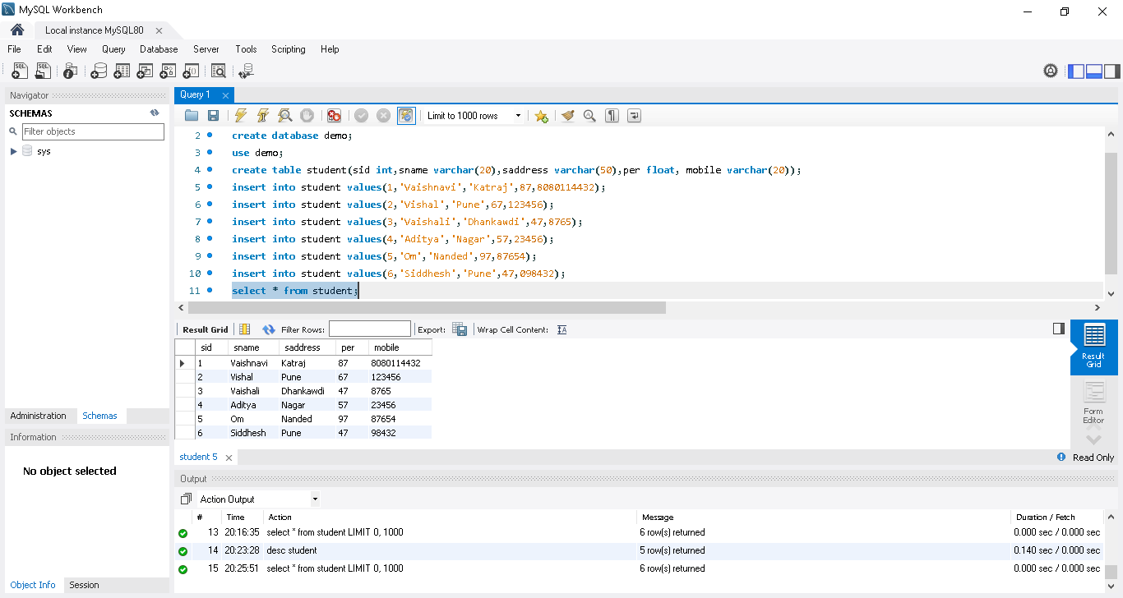

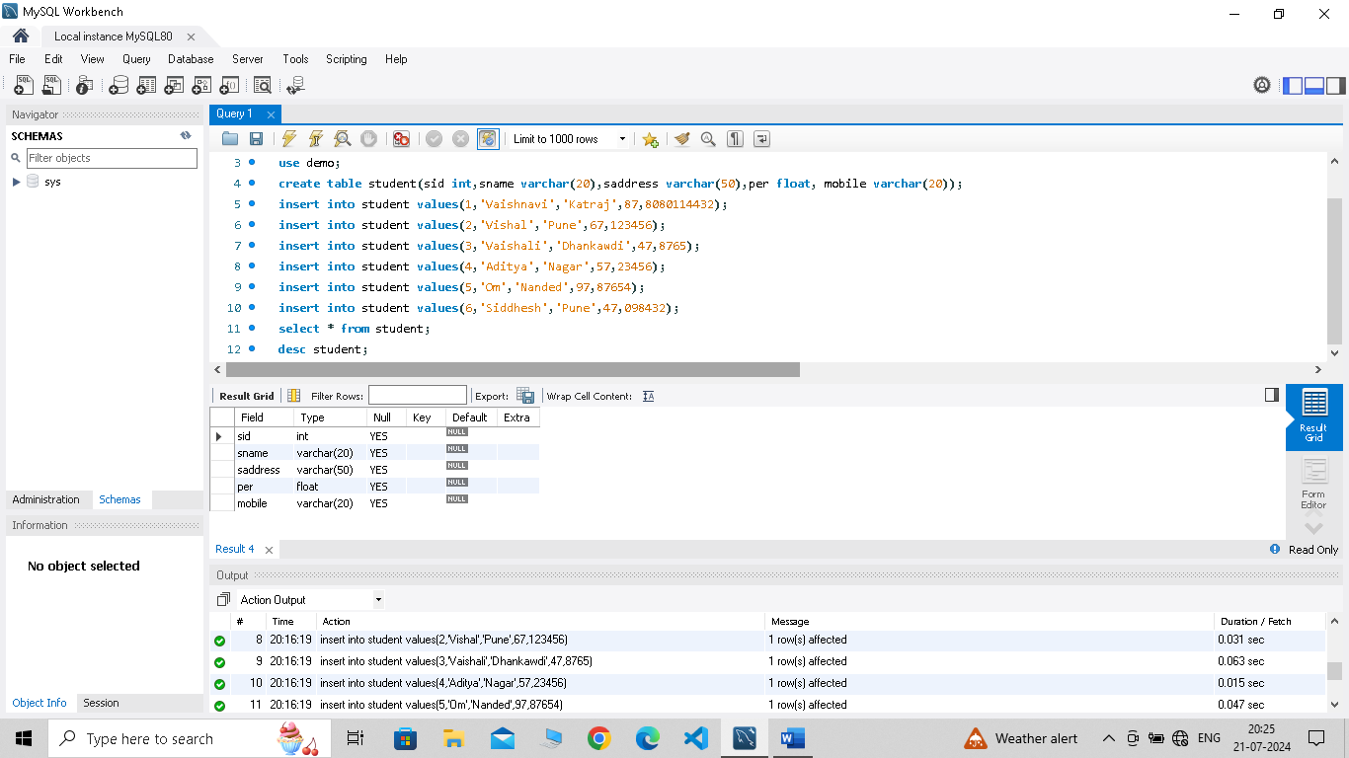

show tables;

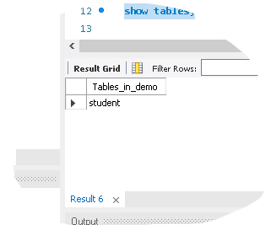

alter table student modify column saddress varchar(60);

alter table student modify column per double;

desc student;

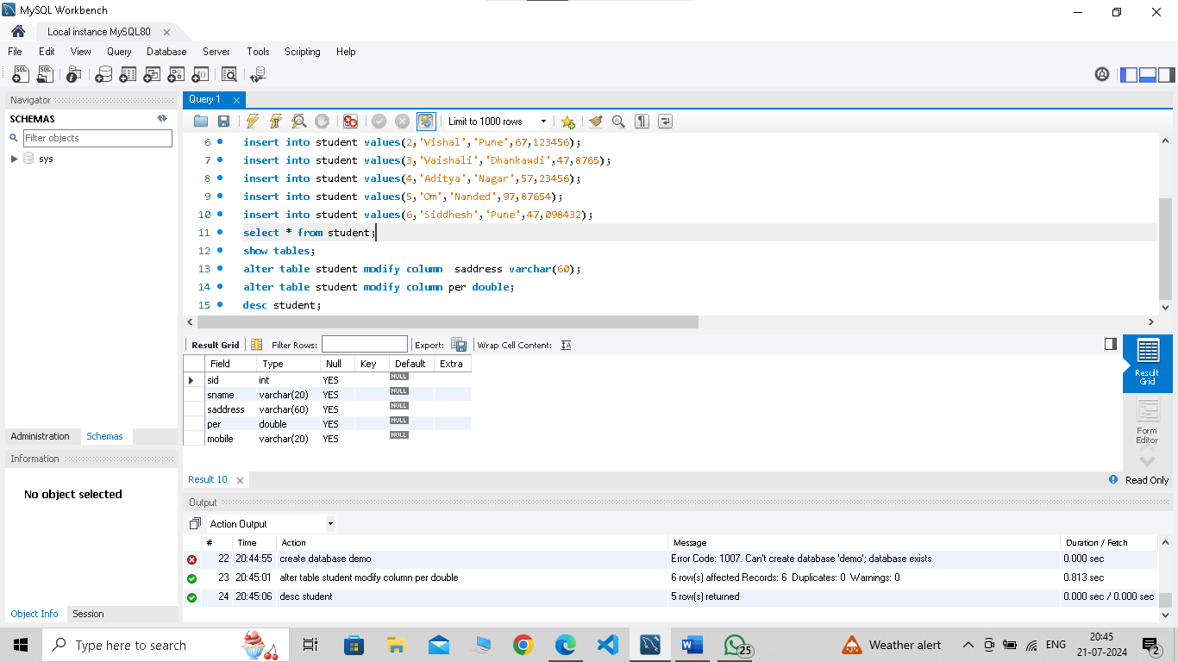

alter table student add column parentsno varchar(20);

alter table student add column state varchar(30);

desc student;

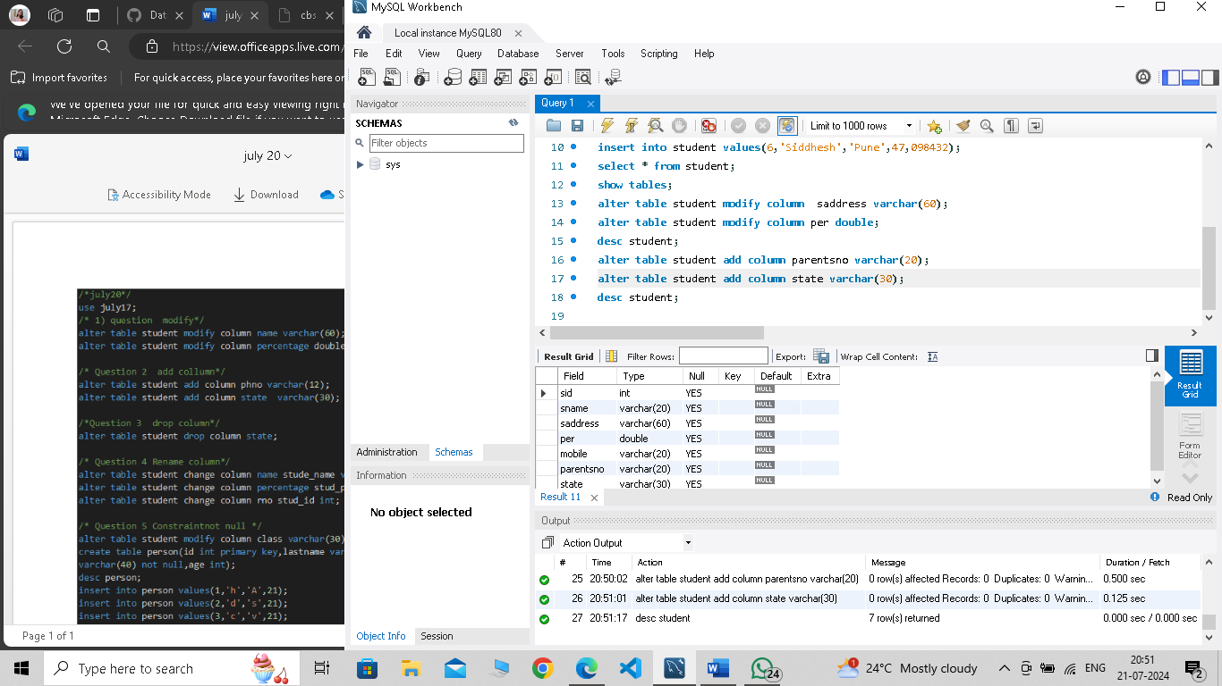

alter table student drop column state;

desc student;

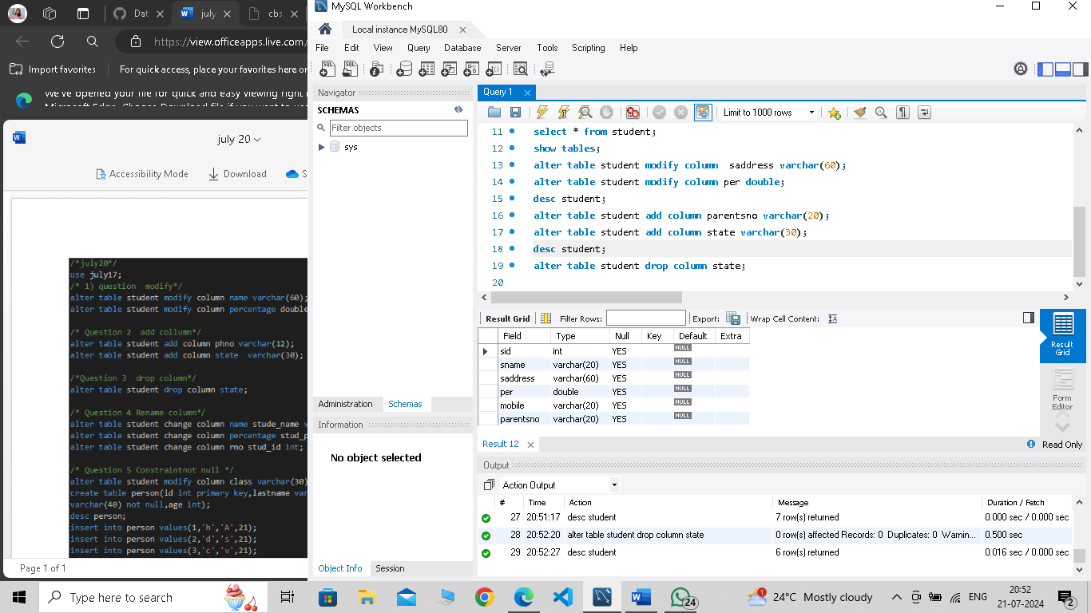

alter table student change column sname name varchar(50);

alter table student change column per percent double;

alter table student change column saddress address varchar(80);

select \* from student;

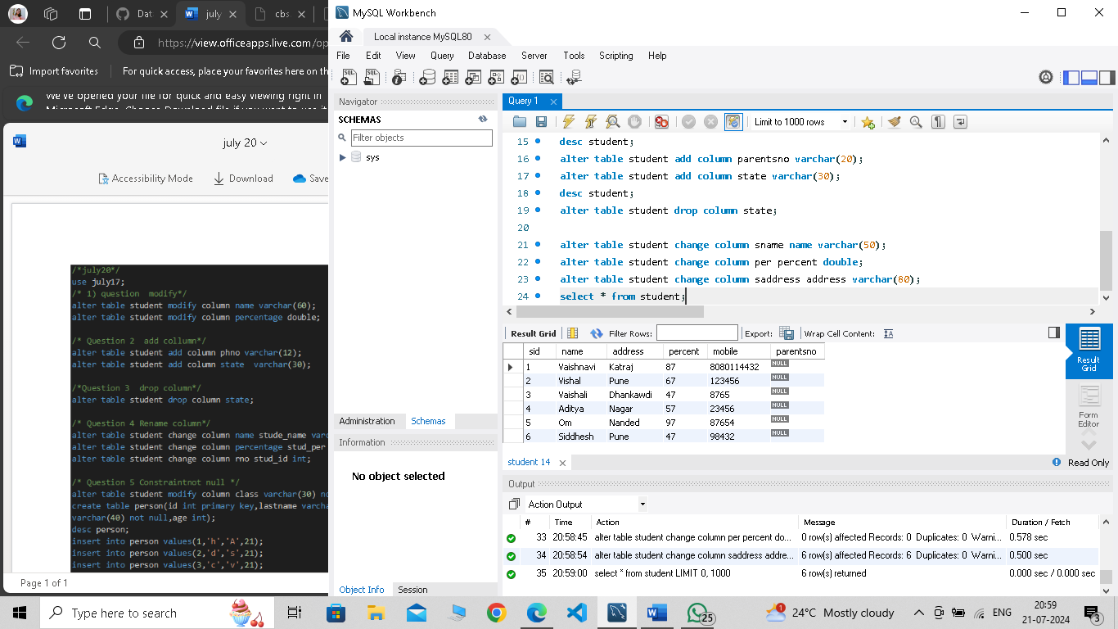

alter table student modify sid int not null;

insert into person values(1,'Vaishnavi','Chaudhari',21);

insert into person values(2,'Siddhesh','Deshmukh',21);

insert into person values(3,'Aditya','Hublikar',21);

alter table person modify column age int not null;

desc person;

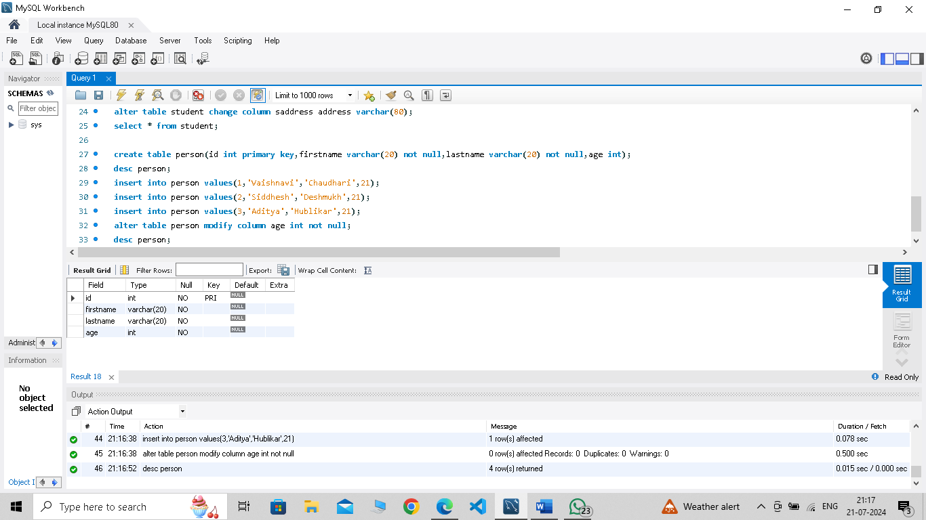

alter table person modify column firstname varchar(20) not null unique;

create table cars(id int primary key,name varchar(20) not null,company varchar(30),constraint unq unique(id,company));

alter table cars add unique(name);

alter table cars drop index unq;

desc cars;

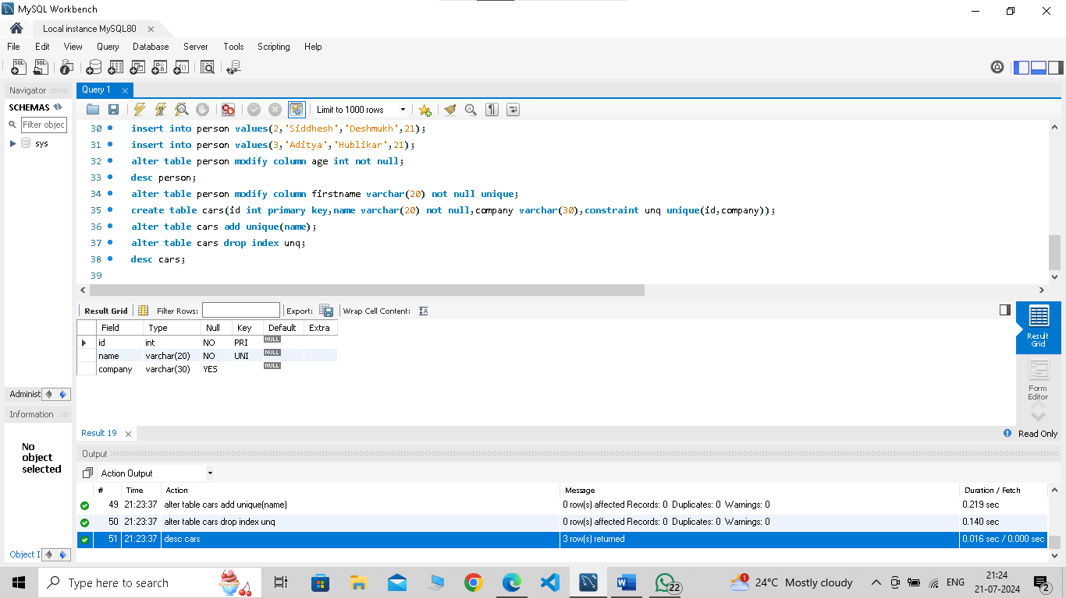

create table student1(id int primary key,name varchar(50) not null,age int not null,standard varchar(20));

desc student1;

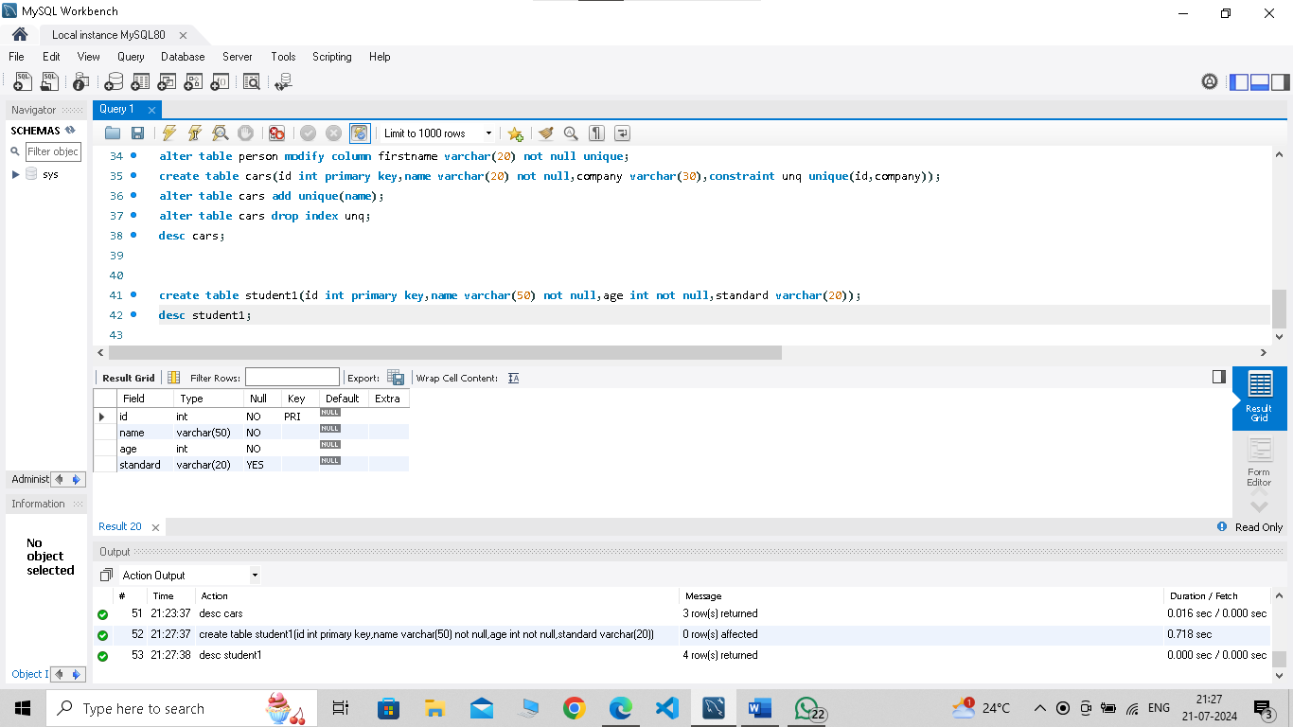

create table student1(id int primary key,name varchar(50) not null,age int not null,standard varchar(20));

desc student1;

alter table student1 modify column age int check(age>=18 and age<=60);

insert into student1 values(1,'Vaishnavi',21,'MSC.CS');

ALTER TABLE student1 modify column standard varchar(30) check(standard='MSC.CS' or standard='TY' or standard='SY');

insert into student1 values(2,'Nitya',21,'TY');